DLD-LAB# 2

Purpose of this Lab:
- Working of logic Works and technique of mounting ICs on it

- Basic idea of AND, OR and NOT gates and their ICs

Operation of AND gate according to its truth table
Install IC (integrated circuit) for AND (74LS08) on the breadboard according to the connection diagram given below.

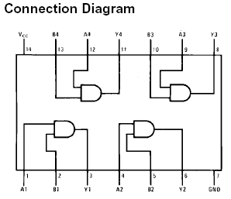

- Fill the truth table according to the results.

Operation of OR gate according to its truth table

Install IC (integrated circuit) for OR (74LS32) on the breadboard according to the connection diagram given below.

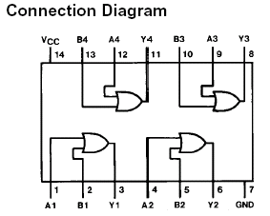

- Fill the truth table according to the results.

Operation of NOT gate according to its truth table

Install IC (integrated circuit) for NOT (74LS04) on the breadboard according to the connection diagram given below.

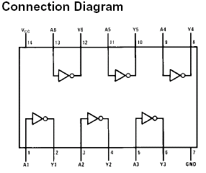

- Fill the truth table according to the results.

